FORECAST OF EXTREME SPACE WEATHER EVENTS. On-line regime

Valery Kozlov - 1 and Vycheslav Kozlov - 2
1. IKFIA SB RAS "Institute of Cosmophysical Research and Aeronomy",
Yakutsk, Russia. cosmoprognoz@mail.ru
2. Arctic Space Weather Center

IDEOLOGY OF CRISIS PHENOMENA
The situation in the solar wind during the maximum of solar activity, when the probability of sporadic phenomena (flares, shock waves, etc.) is high, can be defined as "crisis". Therefore, it is quite natural to apply the ideology of crisis phenomena to describe the process as a whole, namely – "Theory of Failure of Continuous Media" or "Reliability Theory". In this case, higher moments of the distribution function are used in the analysis. More precisely, the generalized three-parameter Weibull-Gnedenko distribution [1] is applied.
To calculate the PROBABILITY of reaching the critical value of cosmic ray (CR) count rate, it is necessary to estimate the shape parameter "c" of the empirical Weibull-Gnedenko distribution, which determines the degree of DEVIATION of the approximating function of the empirical histogram from the normal distribution.
The approximating function of the empirical (integral) histogram of the CR count rate is found by the least squares method. The average values of the CR count rate for each "interval-bin" of the empirical distribution function (integral) histogram will cluster around the fitted straight line, but already in a new coordinate grid (after the double logarithmic procedure and variable substitution). In this case, the tangent of the slope angle of the straight line, fitted by the least squares method, and the free term give the relationships necessary for estimating the sought shape and scale parameters. It is important to note that the shape parameter "c" is the key parameter: when it reaches a critical value, the parameter value is defined as a precursor to reaching a critical, essentially transitional, regime. The scale parameter is determined by the average value (in each "interval-bin") of the empirical histogram of the CR count rate distribution.
Thus, the procedure for extracting a useful precursor signal from a noise-like signal reduces to finding the values of the Hazard Function (by definition - the CR FLUCTUATION PARAMETER) of the Weibull-Gnedenko distribution describing the experimental (integral) histograms of five-minute values of the CR count rate. This allows the extraction of a useful precursor signal from Gaussian noise: Gaussian noise is contained, simply put, in the "linear" part of the Hazard Function, while the sought precursor signal – in the non-linear part. The sought-after, non-linear component of the precursor signal is formed when the calculated probability exceeds the critical value of the analyzed variable, i.e., when P > Pcr.

COSMIC RAY MONITORING
Below, Fig. 1 shows the results of calculating the medium-term (27-day) values of the CR fluctuation parameter for the previous 24th and the beginning of the new 25th cycle. For the calculations, 5-min data from the world network of polar cosmic ray stations (Arctic and Antarctic) of the European Database were used. A pronounced increase in activity was observed from July 2023: medium-term precursors (enclosed in an oval) were recorded on rotations No. 2590, 2592, and 2597, respectively. The precursor in the CR fluctuation parameter on rotation 2597, (January 2024), is of greatest interest, Fig. 1 ([https://www.forshock.ru/predlong.html]{.underline}). Taking into account the forecast lead time Δτ=2(±1 rotation) of the Sun's rotation previously determined by us in [2], intensification of activity was expected on rotation 2599 (±1 rotation), i.e., in February-April 2024. Indeed, a diagnostic marker of the CR fluctuation parameter is recorded on rotation 2599 (the first red dot on the right). Consequently, the maximum of the new 25th cycle began in March 2024 (rotation No. 2599).
According to solar data, starting from the 3rd decade of February 2024 in Active Region (AR) 3590, large X-ray flares of class X1.8 (21.02.2024), X1.7 and X6.3 (22.02.2024) were recorded. Before AR 3590 disappeared onto the solar hemisphere invisible from Earth [https://spaceweather.com/images2024/28feb24/filament_CME.gif]{.underline}, a flare of prolonged and complex M-class structure was observed on February 28-29, accompanied by a series of coronal mass ejections (CMEs).
The beginning of the maximum of the new 25th solar cycle, which started in the 3rd decade of February 2024 (March 2024), becomes increasingly eventful from the end of April through May. This manifested itself in a significant simultaneous intensification of activity in both solar hemispheres [https://spaceweather.com/images2024/05may24/acticity_teal.gif]{.underline}. The appearance of so-called "sympathetic" flares serves as an illustration of the above. First "paired" - in the northern and southern hemispheres), and then serial events recorded over the ENTIRE [https://spaceweather.com/images2024/06may24/m4p5_anim_opt.gif]{.underline} visible solar hemisphere simultaneously.
In the first decade of May, a "paired" precursor (in the form of two half-day values) in the fluctuation parameter ([https://www.forshock.ru/pred.php]{.underline}) for May 5-6, 2024, was obtained (Fig. 2). This precursor was recorded at the beginning of May 6, and already on the 2nd day - May 8, according to data from the ACE spacecraft (USA), an increase in the flux of low-energy protons over a wide energy range began – "storm" particles (Appendix 1), which usually precede the arrival of shock waves (SW) at Earth's orbit. The remarkably high power of this event is most likely due to a cumulative effect (Appendix 2) [3]. In foreign terminology: "cannibal effect" [4].
The extremely high solar activity in May 2024 continued in October-November. This follows from the results of the subsequent medium-term forecast (see Fig. 1). A "double" precursor is recorded on rotations No. 2602-2603 in May-June 2024. After Δτ=2(±1 rot.) solar rotations, starting from August (rotation No. 2605) 2024, a deep and prolonged decline in CR intensity began. This is also indicated by the relatively low - markers of decreasing CR intensity, i.e., diagnostic values of the fluctuation parameter on rotations No. 2607-2608.
The medium-term forecast is confirmed by the results of operational monitoring. Indeed, the "paired" values of the CR fluctuation parameter from 4 to 5 October and from 8 to 9 October 2024 (Fig. 3) exceed the "cosmic noise" region, thereby being precursors of SWs. Conversely, the extremely low - diagnostic values of the CR fluctuation parameter on 5-6 October and 10-11 October are MARKERS of SW registration at Earth's orbit. It follows that in October 2024 (rotation 2607) the MAXIMUM of the new 25th cycle is recorded! This is in good agreement:
[https://www.swpc.noaa.gov/news/joint-solar-maximum-announcement-nasa-and-noaa]{.underline} with data from various types of measurements carried out at NASA and NOAA (USA) Space Centers.
Subsequent results of medium-term monitoring are presented in Fig. 4. After a long lull, a precursor was recorded on rotation 2613 and 2615 (for April-May 2025). The obtained precursors most likely signifies the onset of the geoeffective decay phase of the current 25th cycle at the stage of completion of the inversion of the Sun's general magnetic field. This is confirmed by the results of operational monitoring in May--June 2025, presented in Fig. 5.
Precursors from the same giant active region No. 4079 were recorded twice: on May 13, when AR 4079 disappeared behind the eastern limb of the Sun on May 12, and on May 28 – three days after its return to the visible hemisphere. It is important to note that the precursor on May 13 was recorded from a "limb-beyond" source. The unique possibility of recording precursors in the CR fluctuation parameter from powerful sources of activity on the solar hemisphere invisible from Earth was reported in [5]. It is also noteworthy that during the 2 previous passages of AR No. 4079 across the Sun's visible hemisphere, no significant manifestations of solar activity were recorded.
And only on the 3rd "pass" did AR 4079 manifest itself in the precursor registration on May 28, which preceded the registration of a giant Forbush decrease on June 1-7, with an amplitude of decrease of at least 15%, at the Oulu station. At the same time, an increase in an extremely large flux of "storm" particles (Appendix 3) is recorded on May 31, i.e., one day before the start of the Forbush decrease on June 1, 2025. This is confirmed by modeling results at the NOAA Space Center (USA): Appendix 4. It is worth noting that precisely this kind of "storm" particle fluxes are the main source of damage to control and life support systems in near space, the upper atmosphere, and on Earth!

As noted earlier, in order to determine priorities, NASA (USA) polls the scientific community every 12 years, in this case (2012) specialists in the field of solar physics, about the choice of the most important scientific directions. Based on the results of the poll, a report is compiled, which is called the Decadal Survey. Below are the problems that NASA is going to work on in the next decade:

"1. Determining the mechanism of the eleven-year cycle of solar activity. According to observations, the sun changes its activity with a cycle of 11 years. There are many theories about why this happens, but there is no consensus. This is a fundamental task and its solution is necessary for understanding large-scale changes in the Sun, as well as for assessing the impact of such changes in the Sun on the Earth's climate.
…………………………………………………………………………….
3. The ability to predict changes in space weather. In other words, it is important to know what leads to solar flares, coronal mass ejections, and the emergence of new active regions. Here it is necessary not only to understand what is happening, but also to be able to warn the public about it. At the moment, there is not a single reliable method for predicting flares and coronal mass ejections. However, all this is necessary for the reliable operation of satellites, radio communications, aircraft and power grids."

It is obvious from the above NASA research PROGRAM that the results we have obtained above for the forecast of extreme events of "Space Weather" relate to the content of p. 3 of the said Program. In this regard, it can be stated:

1. The registration of precursors in the CR fluctuation parameter is a sufficient criterion for forecasting the active phase of the solar cycle (with a lead time of Δτ=2(±1 rot.) of the Sun's rotations at a significance level of P ≥90%.

2. Registration of precursors in the CR fluctuation parameter is a sufficient criterion for forecasting "storm" particles (the main source of damage to control and life support systems in near space, the upper atmosphere and on Earth) and interplanetary shock waves (the source of geomagnetic storms). The lead time for detecting "storm" particles and subsequent shock waves is Δτ=3(± 1 day) days at a significance level of P ≥90%.

3. The proposed method is a kind of "all-weather interceptor" that allows "intercepting" a powerful source of activity on the reverse hemisphere of the Sun, invisible from Earth. This is achieved with the help of the Cyber-FORSHOCK Expert Robotic System created by us. In our case, planet Earth with polar stations of the European CR DB (http://www.nmdb.eu) is used as a single "device"!

REFERENCES
1. Aivazyan S.A., Enyukov I.S., Meshalkin I.D. "Applied Statistics. Fundamentals of Modeling and Primary Data Processing". M.: Finance and Statistics Publishing House. 1983. 313 p. (In Russian)
2. Kozlov V.I., Kozlov V.V. Galactic cosmic ray fluctuation parameter -- an indicator of the degree of magnetic field inhomogeneity // Geomagnetism and Aeronomy. 2011. Vol. 51. No. 2. P. 191--201. (In Russian)
3. Kozlov V.I. Forecast of extreme space weather events from cosmic ray fluctuations // Journal "Cosmic Research". 2022. Vol. 60. No. 2. P. 105--115. (In Russian)
4. Scolini C., Chané E., Temmer M., Kilpua E.K.J. et al. CME--CME Interactions as Sources of CME Geoeffectiveness: the Formation of the Complex Ejecta and Intense Geomagnetic Storm in 2017 Early September // Astrophysical J. Supplement Series. 2020. Vol. 247. No. 1. P. 21--27 ([https://iopscience.iop.org/article/10.3847/1538-4365/ab6216]{.underline}).
5. Kozlov V.I. Over-the-horizon detection of a powerful source of activity on the Sun by the "halo" effect in cosmic rays // Journal "Cosmic Research". 2021. Vol. 59. No. 5. P. 1-12. (In Russian).

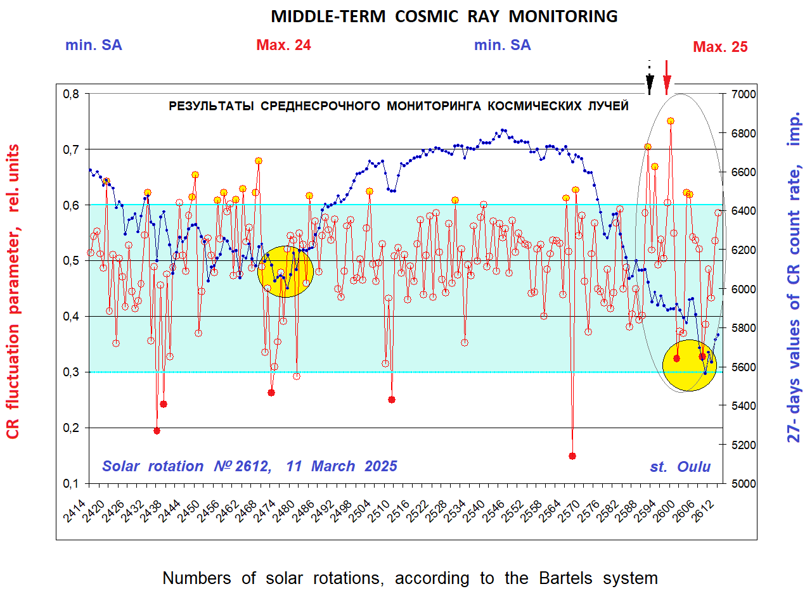

Fig. 1. Cosmic ray count rate of the Oulu station (Finland) in counts per 5 minutes, averaged over 7776 points of 5-min values during each solar rotation - blue dotted curve, right scale, for the time interval starting from rotation 2414-2613. 27-day values of the CR fluctuation parameter in relative units - solid red curve, left scale. The 90% significance level is shown. Values of the CR fluctuation parameter exceeding the "cosmic noise" region (shown in green) are precursors to increased solar activity. The precursor of the beginning of the maximum of the 25th cycle is shown by a black dashed arrow, recorded on rotation No. 2597. A subsequent "double" precursor is recorded on rotations No. 2602-2603 in May-June 2024 (red arrow). Conversely, a sufficiently low --- diagnostic value of the CR fluctuation parameter on rotation 2607 (2nd red point) - OCTOBER 2024, is defined as --- a marker of the MAXIMUM of the new 25th cycle, against the background of the onset of a sharp decrease in CR intensity.

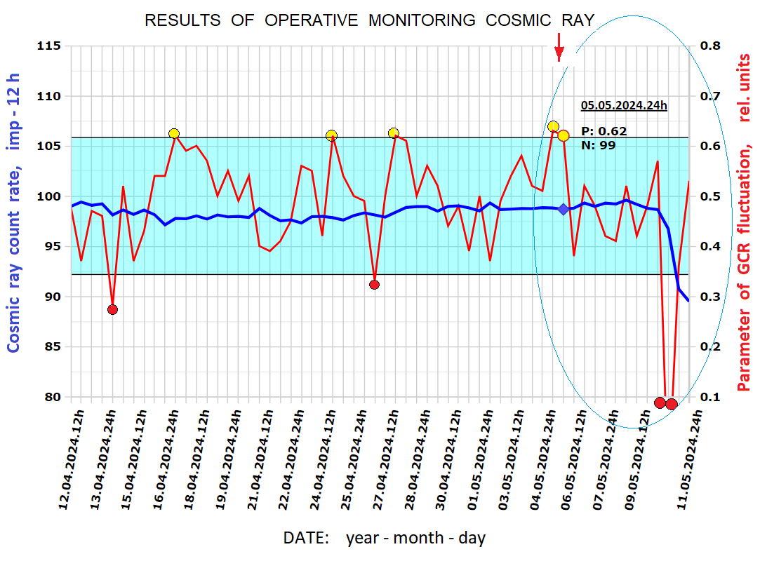

Fig. 2. Results of operational monitoring in April -- May 2024. Ordinate axis: right scale (red curve) - values of the CR fluctuation parameter; left scale (blue curve) - count rate in counts per 5 minutes (averaged over 12 hours) according to the Oulu neutron monitor station (Finland). Parameter values within the interval: 0.35<P<0.60 -- the "cosmic noise" region (shown in green). Abscissa axis -- date: year -- month -- day - hour. "Paired" values of the CR fluctuation parameter on May 5-6, 2024, exceed the "cosmic noise" region and are therefore precursors of SWs. Conversely, the extremely low - diagnostic values of the CR fluctuation parameter from May 10 to 11 are markers of shock wave registration at Earth's orbit.

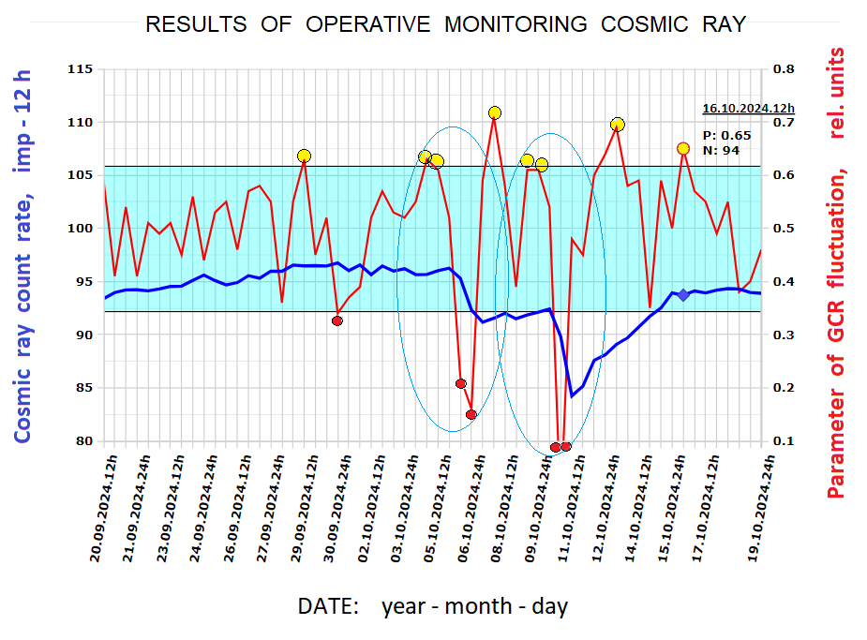

Fig. 3. Results of operative monitoring in September–October 2024. Ordinate axis: right scale (red curve) - values of the CR fluctuation parameter; left scale (blue curve) - count rate in counts per 5 minutes (averaged over 12 hours) according to the Oulu neutron monitor station (Finland). Parameter values within the interval: 0.35<P<0.60 -- the "cosmic noise" region (shown in green). Abscissa axis -- date: year -- month -- day - hour. "Paired" values of the CR fluctuation parameter on October 4-5 and 8-9, 2024, exceed the "cosmic noise" region and are therefore precursors of SWs. Conversely, the extremely low - diagnostic values of the CR fluctuation parameter from October 5-6 to 10-11 are markers of shock wave registration at Earth's orbit.

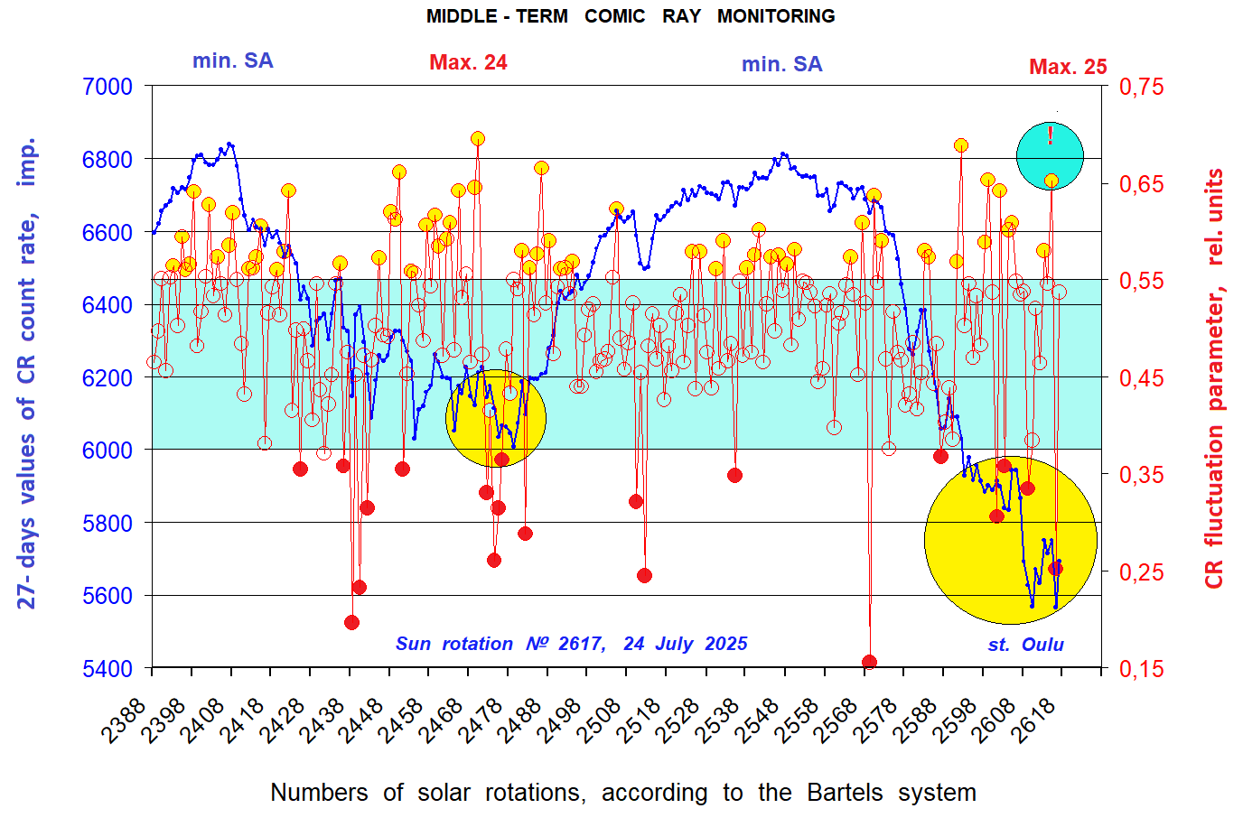

Fig. 4. Cosmic ray count rate of the Oulu station (Finland) in counts per 5 minutes, averaged over 7776 points of 5-min values during each solar rotation - blue dotted curve, left scale, for the time interval starting from rotation 2388-2616. 27-day values of the CR fluctuation parameter in relative units - solid red curve, right scale. The 90% significance level is shown. Values of the CR fluctuation parameter exceeding the "cosmic noise" region (shown in green) are precursors to increased solar activity. The precursor of the completion of the inversion of the Sun's general magnetic field at the beginning of the decay phase of the new 25th cycle, recorded on rotation No. 2615 (for May 31, 2025) - marked by a red "!" symbol.

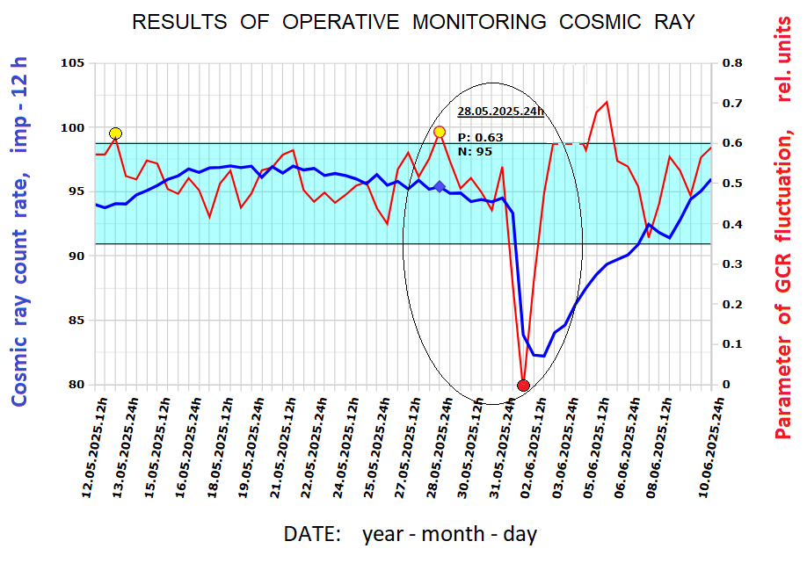

Fig. 5. Results of operational monitoring in May -- June 2025. Ordinate axis: right scale (red curve) - values of the CR fluctuation parameter; left scale (blue curve) - count rate in counts per 5 minutes (averaged over 12 hours) according to the Oulu neutron monitor station (Finland). Parameter values within the interval: 0.35<P<0.60 -- the "cosmic noise" region (shown in green). Abscissa axis -- date: year -- month -- day - hour. Precursors from the same giant active region No. 4079 were recorded twice: on May 13, when the AR disappeared behind the eastern limb of the Sun on May 12, and on May 28 – three days after its return to the visible hemisphere. It is noteworthy that during the 2 previous solar rotations, no significant manifestations of solar activity were recorded. The precursor on May 28 preceded the registration of the giant Forbush decrease on June 1-7, with an amplitude of decrease of at least 15% at the Oulu station.

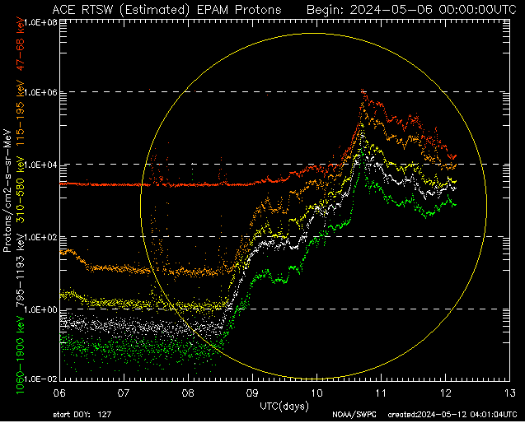

Appendix 1. Giant flux of "storm" particles with energy ɛ ≈ 50-2000 keV according to the ACE spacecraft data from May 6-12, 2024.

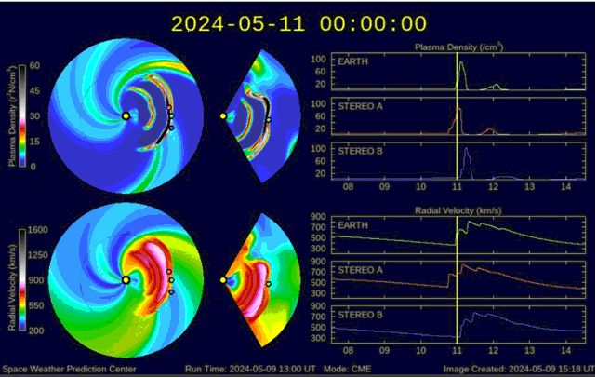

Appendix 2. Results of modeling the situation May 8-11, 2024 at the NOAA Space Weather Prediction Center. The shock wave crosses Earth's orbit on May 10-11, which confirms the presence of a marker in CRs -- an extremely low, i.e., diagnostic value of the CR fluctuation parameter. The modeling results are a good illustration of the cumulative effect [3] (the "cannibal effect", in foreign terminology [4]) of shock wave interaction.

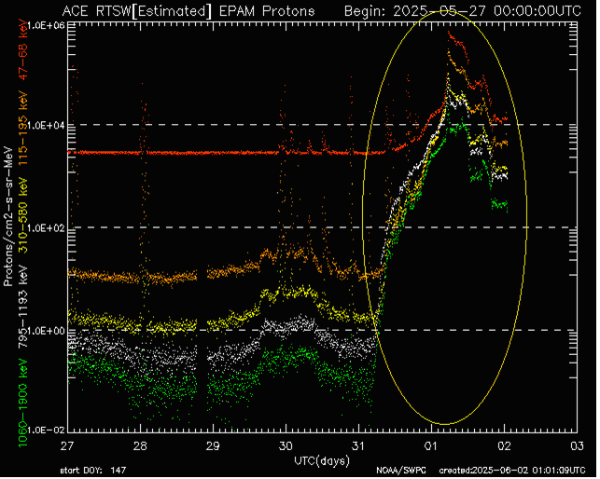

Appendix 3. Giant flux of "storm" particles with energy ɛ ≈ 50-2000 keV according to the ACE spacecraft data from May 31 -- June 1, 2025. AR 4079 manifested itself in the precursor registration on May 28, which preceded the registration of the giant Forbush decrease on June 1-7, with an amplitude of decrease of at least 15%, at the Oulu station. At the same time, an increase in an extremely large flux of "storm" particles is recorded on May 31, i.e., one day before the start of the Forbush decrease on June 1, 2025. It is worth noting that precisely this kind of "storm" particle fluxes are the main source of damage to control and life support systems in near space, the upper atmosphere, and on Earth!

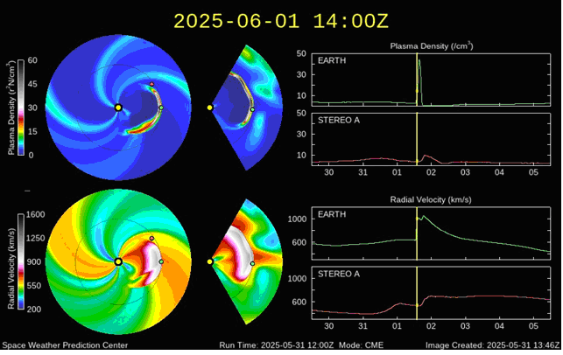

Appendix 4. Results of modeling the situation May 30 -- June 4, 2025 at the NOAA Space Weather Prediction Center. The shock wave crosses Earth's orbit on June 1, which confirms the presence of a marker in CRs -- an extremely low, i.e., diagnostic value of the CR fluctuation parameter -- on June 1, 2025.

